To: Armin Eilaghi

From: Hi-Jacks

Date: 1/29/2023

Re: Engineering Model Summary

Top Level Design Summary
Team Hi-Jacks is working to design and create a fully functional drone that optimizes power, weight, and flight time that will, in the future, be used for land surveying. The drone uses a very simple design (figure 1) with three central plates to hold the electronic components. Each arm acts as a spacer between plates along with another set of spacers connected to the arms where the motors are placed at the ends. The legs clamp onto the bottom of the spacers to give the drone a wide stance while on the ground and to make for easier landings.

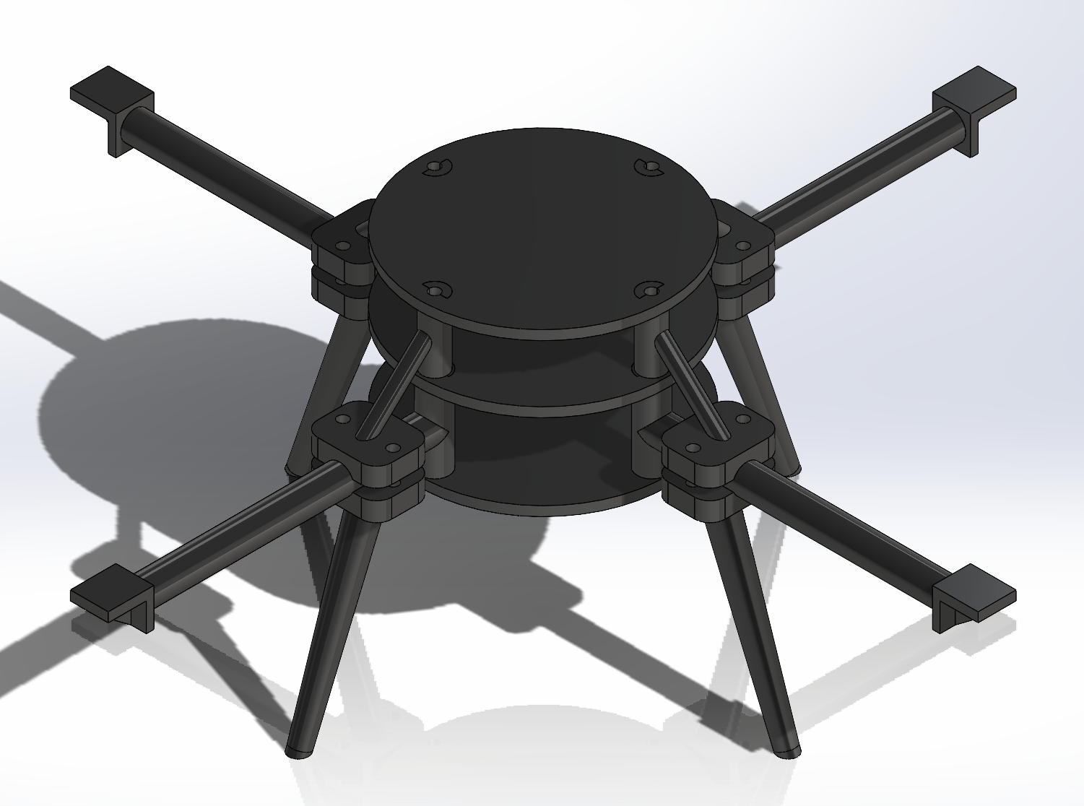
Figure 1: CAD model of current design
For the project, the customer had a certain set of requirements to design around. They wanted a high thrust to weight ratio, lightweight, optimized component location, low cost, long flight time, and the use of minimal hardware. To achieve these requirements, the team made a list of engineering requirements to ensure the customer needs are met. These are a weight of less than three pounds, a thrust to weight ratio of over 1.81, necessary components have a wide field of view, a centralized and non-moving center or gravity, and a project cost under $5,000. These requirements are detailed in the QFD in appendix A.

Summary of Standards, Codes, and Regulations
FAA regulations on drone flying set the maximum allowable heights for flight of a drone. This was used to analyze needed strength of the drone as discussed in the next section. The maximum allowable height was set as the worst-case scenario for a drone falling and impacting the ground.

ASTM-D638 Type 1 is a set of standards that defines tensile testing. The team had performed these tests in the previous semester according to these guidelines. The dog bone testing of these materials applies to these standards as all samples are created the same way, are tested in similar conditions, and are compared to each other to form an overall conclusion. This standard is applicable to reinforced plastics being tested under a variety of temperatures, humidity, and testing machine speeds. The team printed multiple ASTM-D638 Type 1 dog bones made of different materials that would be strength tested in a universal tensile tester. The values for tensile strength gained from these tests would then be used to calculate the physical limits of the drone.

Summary of Equations and Solutions
Normal Operation
In order to determine the factors of safety for each of the components during flight, it is important to use the stress values when they reach the maximum amount. For the case of an operational drone, the highest stress values will occur upon liftoff and landing and in most cases will be far greater when landing if the operator is unable to easily control the drone. In addition to assuming that the stresses are at a maximum upon landing, there will be other assumptions that will need to be made in order to accurate solve for the stresses and this includes the velocity of the drone when it touches down, the weight of the drone with all of the components attached, and with these values, the force of impact can be calculated using equation 2 found in Appendix B.

All of the work in order to solve for the stresses of each of the parts can be found in Appendix B and the assumptions are stated as well. To safely operate the drone, the team, along with the Boeing Client, has decided that the minimum factor of safety for each of the parts should be 1.2.

Table 1: Individual Part Factor of Safety Normal Operation
Sub-System | Part | Load Case Scenario | Material | Minimum FoS
Body |  | Normal Operation |  | 1.2
 | Plate with key |  | ABS
 | Plate with no key |  | ABS
 | Arm |  | ONYX
 | Leg |  | ONYX
 | Leg connector |  | ONXY
 | Body bolts |  | Zinc coated Grade 2 Steel
 | Leg bolts |  | Zinc coated Grade 2 Steel

Crash Landing
Although crashing is not considered a part of normal use for the drone, the team felt it was important to consider the effects of a crash. Using the FAA 400ft and by analyzing the various accelerations during a crash, it would be possible to interpret the forces received by different components. The resulting force from a worst-case scenario crash was 770 N, which could have negative effects on the drone depending on the location of impact. This situation however is unlikely to occur, so the team decided to not focus on overbuilding the drone for the unlikely event. Instead, the team focused on preparing the drone to withstand forces seen in normal use as discussed above.

Flow Charts and Other Diagrams
The functional model takes the drone and breaks it into individual steps. Starting from the input by the human controller, intermediate steps are identified through to a final output by the propellers as thrust. The functional model then identifies any energy involved with a respective step. The final functional model can be seen in Figure 2.

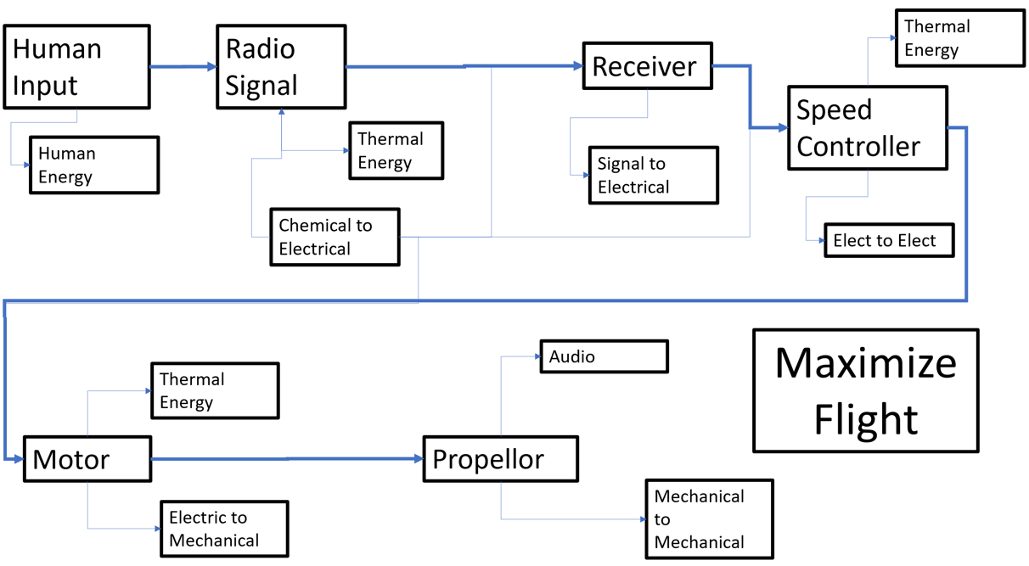
Figure 2: Drone Functional Decomposition

The functional model helped the team identify components associated with each step as required for flight. It then provided the energy associated with each of these steps. For concept generation, this was useful as it provided topics that would need to be designed for… such as the arm and body configuration. Because the team is focusing on the body of the drone and components were pre-selected by Boeing, the functional decomposition was used less for the selection of individual components. It was instead used as a template for how the components connect and gave a deeper understanding into how drones function. After understanding these concepts, the team used the Black Box Model and functional decomposition to begin concept generation.

Moving Forward
Team Hi-Jacks has put a considerable amount of thought and calculations into the design stages of creating the drone body. The symmetry of the arms, legs and body of the drone frame simplifies the center of gravity (CoG) calculations as the only components being added to the drone are electrical. All parts of the manual flight drone will be with the team by early next week, which assists the team calculations of weight and symmetrical placement without assumptions. All the components will need finalized placement sections inside of the body to begin accurate CoG calculations. Concerning material testing of the drone, non-reinforced Onyx polymer 3D printing from a Markforged printer proved to be the most durable and versatile material for the purposes of the drone based on last semester's dog bone tests. No further material testing is planned to be re-run but could be crucial after the drone is properly operating and problems are observed with material fatigue.

Calculations that will be actively used within the team involve ANSYS stress testing, ANSYS flight simulation, and CoG changes. The weight of the drone will not change until a new prototype is made with longer arms, rounded edges, wiring management and a fastening mechanism for the electrical components. There are many calculations and simulations to come in this project but not at the expense of an incomplete drone body with corresponding weights. The team is confident that the drone will be ready for ANSYS simulations and CoG calculations within the next two weeks following the update of the drone frame and weight of the new electrical devices.

References
[1] R.G. Budynas and J.K. Nisbett, Shigley’s Mechanical Engineering Design. New York, NY: McGraw-Hill Education, 2020.
[2] Engineering mechanics. Upper Saddle River: Pearson Education (US), 2015.
[3] “Material DATASHEET composites - markforged.” [Online]. Available: https://www-objects.markforged.com/craft/materials/CompositesV5.2.pdf. [Accessed: 30-Jan-2023].
[4] “Standard hex head cap screws,” Standard Hex Head Cap Screws - Grainger Industrial Supply. [Online]. Available: https://www.grainger.com/category/fasteners/bolts/hex-head-bolts/standard-hex-head-cap-screws?attrs=Fastener%2B%2BLength%7C6%2Bin~~Material%2BGrade%2FClass%7CGrade%2B2~~Material%7CSteel~~System%2Bof%2BMeasurement%7CInch~~Thread%2BSize%7C1%2F4%22-20&filters=attrs. [Accessed: 29-Jan-2023].
[5] “Strength at yield (tensile),” Strength at Yield Tensile. [Online]. Available: https://omnexus.specialchem.com/polymer-properties/properties/strength-at-yield-tensile?id=305&src=om-selectionguide&utm_source=selection-resources&utm_medium=guide&utm_campaign=ABS_profile. [Accessed: 29-Jan-2023].

Appendix A: QFD

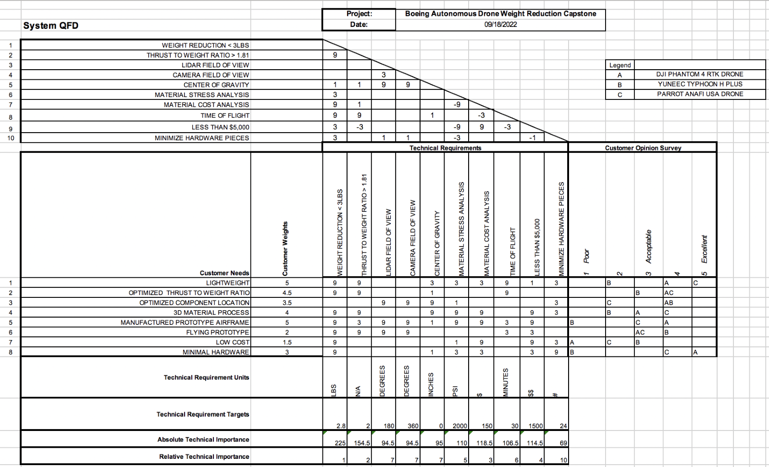

Appendix B: Factor of Safety Calculations
